Nepal College of Information Technology
Assessment Fall 2013

Program : BE IT_Morning Time : 3 hrs
Semester : Fall (III) FM : 100
Subject : Data Structure and Algorithm PM : 50

- Candidates are requested to give their answer as far as practicable in their own words.
- The figure in the margin indicates the full marks
- Attempt ALL question

- a) Define Stack. Convert the following infix expression into postfix using stack. (( A - ( B + C )) * D ) / ( E + ( F * G )) [7]
b) What are the advantages of circular queue over linear queue? Write an algorithm to enqueue and dequeue element into/from linear queue.[8]
- a) What are the advantages and disvantages of linear linked list? Show an algorithm to insert an element at the end and at specified position of the single linked list. [7]
b) What is doubly linked list (DLL) and circular linked list (CLL). Explain stack as a linked list. [8]
- a) What are the properties of AVL tree? How does single and double rotation takes place in order to balance a tree. Explain with an example. [7]
b) What are strictly binary tree and complete binary tree? Construct a binary search tree (BST) out of following data and traverse them in in- order, pre-order and post-order. [8]
29, 17, 84, 9, 20, 38, 92, 19, 24, 55, 44, 40, 49, 45.
4. a) What is sorting? Explain the divide and conquer approach in quick sort algorithm. Trace the algorithm to sort the following unordered list. 40, 20, 10, 80, 60, 50, 7, 30, 100 [7]

b) What is bucket sort? Perform radix sort from the following sequence of unordered list.
102, 1012, 985, 768, 56, 1233, 568, 670, 490, 1246 [8]

5. a) Write the algorithm for binary search technique. Illustrate it by an example. When is the binary search technique efficient? [7]
- Define the terms hashing, hash function and collision. Given input {1,16,49,25, 64,0,81,4,9} and a hash function h (x) = x mod 10. Show the resulting: [8]
- Hash Table using linear probing.
- Hash table using chaining.
6. a) What is minimum spanning tree? Find minimum spanning tree for the given graph using Kruskal's algorithm. [7]
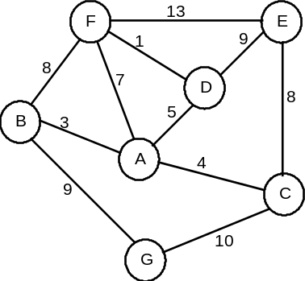
b) Describe the terms isomorphic graph, degree of a node, loop, cycle, connected graph, unconnected graph and spanning forest in reference with graph as ADT. [8]

7. Short notes on (Any Two) [2*5 = 10]
i. Recursion vs Iteration
ii. Big OH notation
iii. Serial and Parallel algorithm
iv. Merge sort

